DIGITAL THERMOMETER

1. Introduction
This project demonstrates how to interface a 16×2 LCD display with an Arduino UNO using a breadboard and basic electronic components. The circuit is commonly used in beginner and school-level electronics projects to display sensor values or system messages.
Based on the circuit shown, the Arduino controls a 16×2 LCD in 4-bit mode and uses supporting components such as a potentiometer for contrast control and LEDs for indication.

2. Objectives

- To understand interfacing of a 16×2 LCD with Arduino UNO
- To learn basic breadboard connections
- To display text or values on an LCD screen
- To understand the use of a potentiometer for LCD contrast

3. Components Required

- Arduino UNO
- 16×2 LCD display
- Breadboard
- 10kΩ Potentiometer (for LCD contrast)
- Resistors (220Ω – 1kΩ)
- LEDs (Red / Green – as shown in circuit)
- Jumper wires
- USB cable for Arduino power and programming

4. Circuit Description

LCD Pin Connections (16×2 LCD)
LCD Pin | Function | Arduino Connection
1 | GND | GND
2 | VCC | 5V
3 | V0 (Contrast) | Middle pin of potentiometer
4 | RS | Digital Pin (e.g., D7)
5 | RW | GND
6 | EN | Digital Pin (e.g., D6)
11 | D4 | Digital Pin (e.g., D5)
12 | D5 | Digital Pin (e.g., D4)
13 | D6 | Digital Pin (e.g., D3)
14 | D7 | Digital Pin (e.g., D2)
15 | LED+ | 5V via resistor
16 | LED− | GND
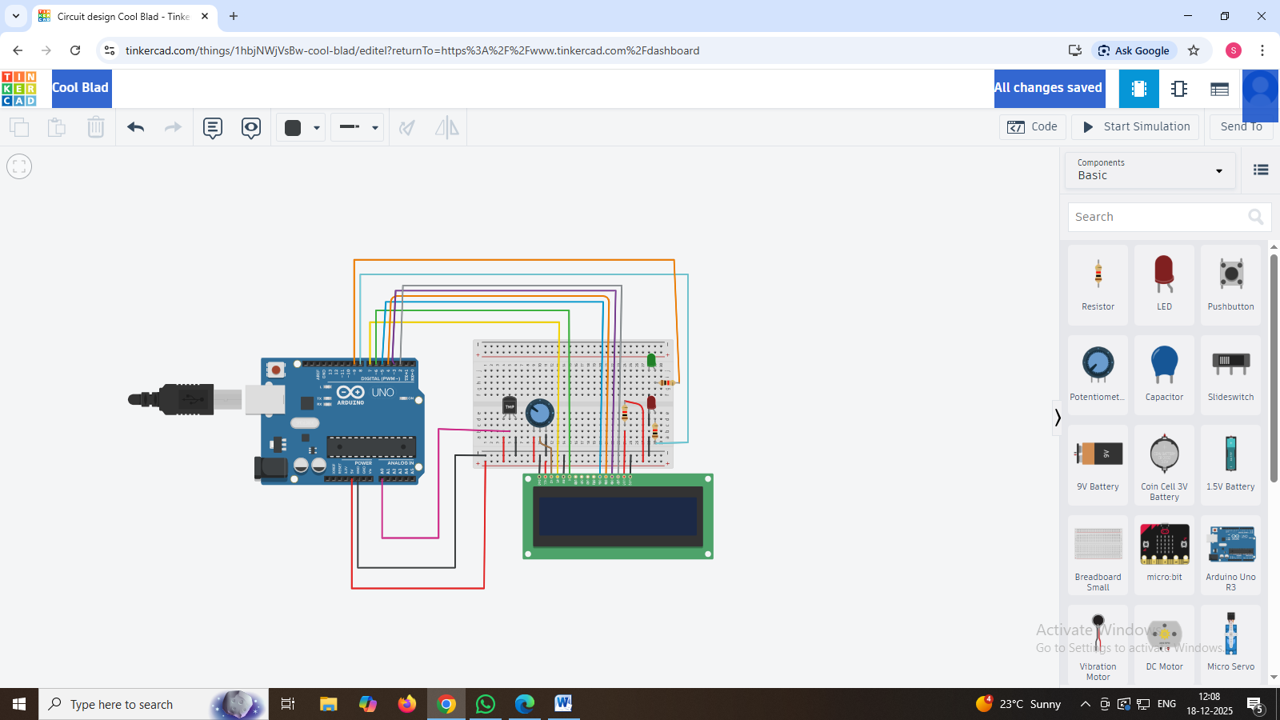

5. Working Principle

- The Arduino UNO sends data to the LCD in 4-bit mode, reducing the number of required pins.
- The potentiometer adjusts the contrast of the LCD display.
- When the Arduino is powered, it initializes the LCD.
- Predefined text or sensor values are displayed on the LCD.
- LEDs can be used as status indicators (ON/OFF conditions).

7. Applications
- School and college mini projects
- Sensor value display (temperature, gas, distance, etc.)
- Embedded system learning kits
- Control panels

8. Advantages
- Simple and low-cost project
- Easy to understand for beginners
- Useful for learning Arduino basics

